**Planning a personalized travel itinerary**

1. **Introduction**
   1. **Background**

Tourism industry has witnessed a tremendous growth in past few years and it expects to grow at 3-4% on yearly basis in future. In the era of digital, most companies are focusing of hyper customers and hence tourism industry has also been focusing on customized offers for customers. This project is based on one such hypothetical tourism company named **Personal Travel Guide** (a startup), which provides complete package for personalized travel plans (Travel, accommodation and food) to customers based on their very specific requirements. It claims to provide the complete solution for the travel so that the customer need not to worry about anything during the travel and stay and can enjoy the tour at fullest.

Personal Travel Guide has got its first customers in Mr. and Mrs. Sinha. Mr. and Mrs, Sinha are going on a holiday after a long time to take a break from their busy schedule and want to enjoy their break at fullest without any stress of planning and arranging things on the spot.

* 1. **Problem**

The Sinhas have decided to go to New York for a five-day tour and they have approached Personal Travel Guide to plan their trip. They have mentioned few specific requirements for their trip based on which they want their trip planned-

1. 5 day stay in New York
2. Hotel should be in the central location of the city from where all the main tourist points are nearby. Hotel should have good ratings, an excellent view and should have amenities such as swimming pool, breakfast on bed, TV and a refrigerator in room.
3. A detailed plan of every day itinerary including the tourist points to cover and famous eating joints around those points.
4. Famous night clubs and Indian restaurants near the Hotel.
5. Famous places to shop near the Hotel
6. **Data Description**
   1. **Data Required**

Following data will be required for this project:

1. List of Hotels in central New York, their ratings and reviews, amenities provided by them
2. List of famous tourist points and their distance from the list of hotels obtained in 1st point
3. After the finalization of hotel, list of night clubs and Indian restaurants near the hotel and their ratings and reviews
4. List of shopping places near the selected hotel and their ratings and reviews
   1. **Data Source**

The data for this project is taken from Foursquare API. The list of hotels, restaurants, tourist destinations and night clubs based on popularity and other requirements such as distance and user ratings can be extracted from foursquare.

1. **Methodology**

**Hotel selection:**

* List of hotels in central New York (within 5 km radius) will be extracted from Foursquare.
* Hotels with the required amenities (Breakfast on Bed, swimming pool, TV and refrigerator) will be filtered from the list
* The filtered list of hotels will be checked against user reviews and the ones having ‘excellent/good view’ and an average rating greater than 4/5 will be selected
* A list of most famous tourist points will be extracted from Foursquare and their distances from the list of hotels obtained will be calculated to get the hotel with minimum distance from all the selected tourist points for 5 days

**List of tourist points to cover every day:**

* Obtain 40 most popular venues within 20 km radius of selected hotel
* Perform Cluster analysis on these venues and divide them in 5 clusters based on distance from the hotel (5 clusters for 5 days)
* Tourist points in each cluster will be covered each day of the 5 day stay
* Most famous restaurants with 500 m radius of each tourist point will be extracted from Foursquare.

**List of Indian restaurants, shopping places and night clubs near the hotel:**

* List of most famous Indian restaurants, shopping places and night clubs within 1 km radius of the hotel will be extracted from Foursquare and top 5 locations will be selected in each category based on user ratings and reviews.

1. **Result**

Map of selected hotel and most popular venues around the hotel

Hotel – red circle

Nearby most popular venues – blue circles

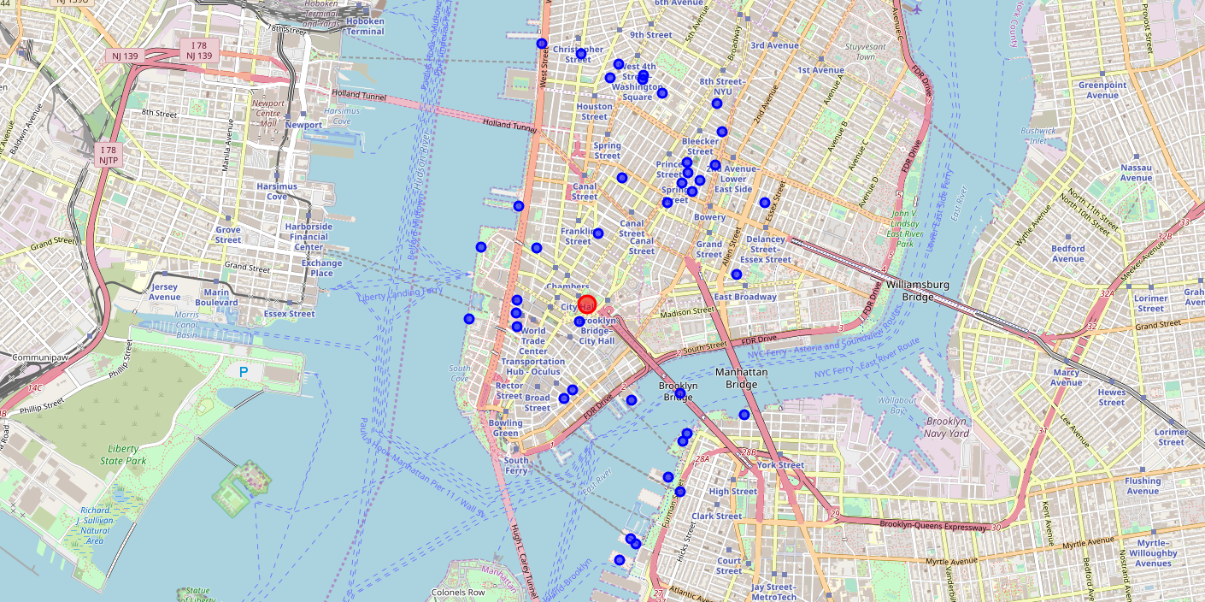

Snapshot of cluster labels for venues

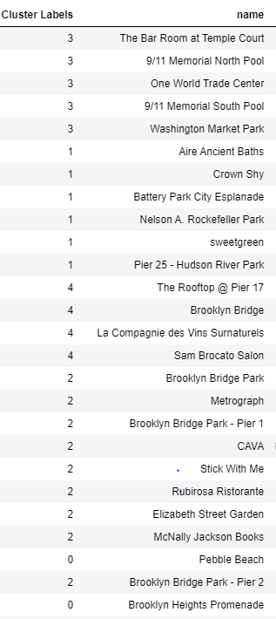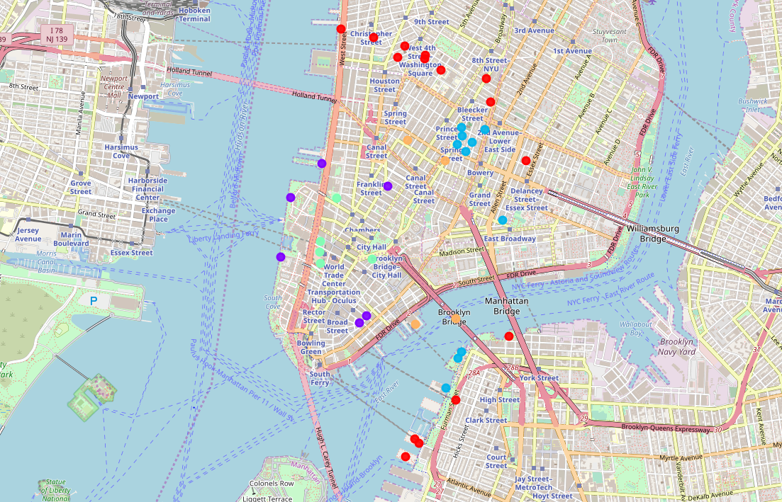

List of 5 most popular shopping places near the hotel

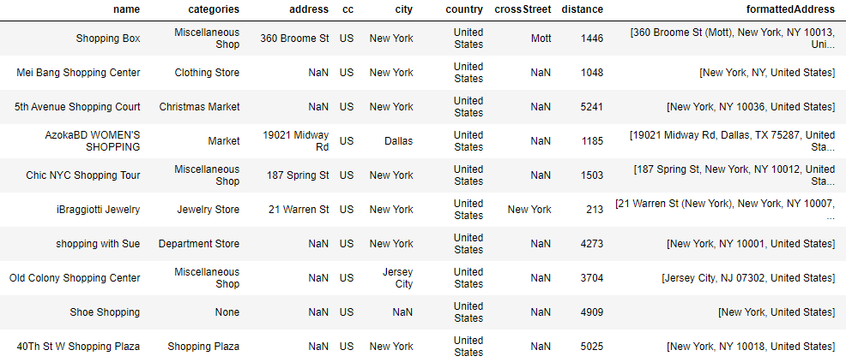

List of 5 most popular Indian restaurants near the hotel

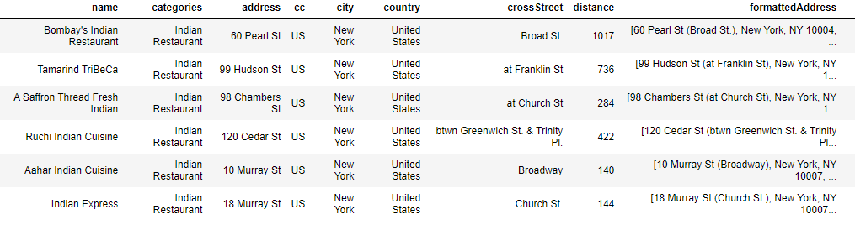

List of 5 most popular night clubs near the hotel

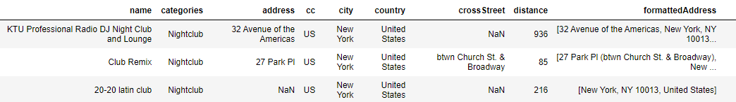

1. **Discussion**

The project had several limitations in terms of using the data from Foursquare. Due to limitations of number of calls from Foursquare, I could not perform the detailed analysis for the hotel selection. Therefore, I had to select one hotel randomly and continue with the rest of the project if it was the selected hotel after following all the steps mentioned in Methodology section.

1. **Conclusion**

The adopted methodology can be adopted for any place and a detailed trip planning can be done based on the requirements specified by the customer. More filters can be applied such as budget constraints and best time to visit a place etc.